About University Management System:

In University, a large amount of data is processed and the results are used in running an organization. The University management system maintains the list of colleges and their different streams along with the examination and result department. There are menus and sub menus in the output of the project which has given this project an organized look.

To maintain the record of colleges, students, examination and result, the university management department prepares the record for each department, showing the total number of colleges and students. It also keeps track of any modification necessary related to students and colleges, and produces regular reports for the organization giving the total information required.

The university data file of this university management system project contains the following:

1. **Details of College information**: In this section, the project keeps the record of college id, college name, college location, college running the stream and the degree the college is running, and maintains the information in college.dat file.
2. **Details of Student information**: In this section, the university management system keeps the [record of student](https://www.codewithc.com/mini-project-in-c-student-record-system/) id, student name, student address, father’s name, contact number, degree stream, std code, and others relevant data.

The project is developed using the class concepts of C++ programming language, and a number of user defined header files are used as well. Many data functions can be found in the project through which any one can know about any student or college by providing the respective student or college number.

### Screenshots:

There are different output screens for most of the functions listed above; I have listed a few output screens of University Management System below. You can find all the output screens documentation within the project folder of the downloaded file.

[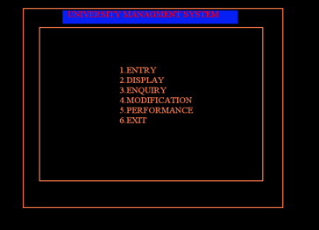](https://www.codewithc.com/wp-content/uploads/2014/08/main-menu.png)

[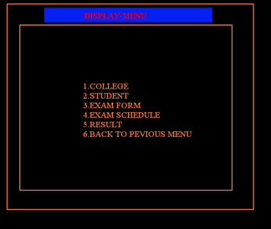](https://www.codewithc.com/wp-content/uploads/2014/08/display-menu.png)  
[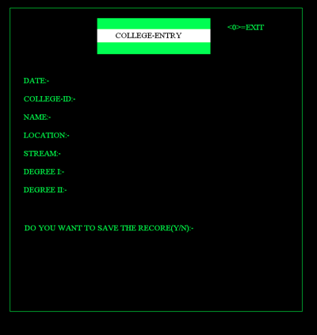](https://www.codewithc.com/wp-content/uploads/2014/08/college-entry.png)  
[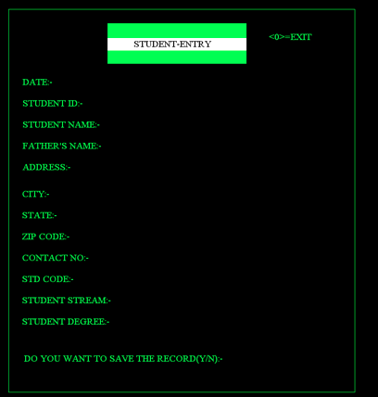](https://www.codewithc.com/wp-content/uploads/2014/08/student-entry.png)  
[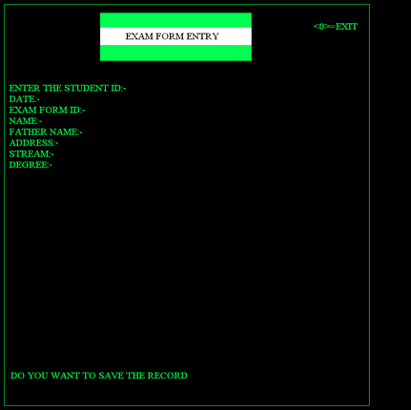](https://www.codewithc.com/wp-content/uploads/2014/08/exam-form-entry.png)

Overall, University Management System project is basically written with C++ class concepts and functions. Its future scope lies in the fact that it can be used in conjunction with other programs of the university for the future development of University Management System. You can add new features and components into this proposed software to make it a even better one.